Case study: AT3545 laser
Subject: BER Prediction based on Laser Bias and Laser Module Features
Authors: Morteza Ziyadi
Date: 03/17/2017
Detail:
In this report, we aim to predict the BER based on different features of the laser module and laser bias. We use the following features for this purpose. It should be note that this analysis is run on the 943 laser modules that 87 units are failed the BER. Also, in previous analysis we just considered the effect of SMSR, CNR, CSO, and CTB, but, in this report we look into all other features.
'Laser SMSR','CNR_61-laser', 'CNR_745-laser','CSO_Minus_61-laser', 'CSO_Plus_547-laser', 'CTB_295-laser',
'WaveLength-laser','ThresholdCrrt-laser', 'SlopEff-laser', 'LsrDistortion-laser', 'Attenuation_Raw-laser',
'Result Laser Bias mA(S21)',
'Result Ave db(S21)', 'Result digipad count(Distortion)',
'CNR_55_25', 'CNR_77_25', 'CNR_205.25',
'MER_741', 'MER2','BER_999'
Target: ‘BER_test'

The first analysis, we take a look at the histograms of the different features. Following is the result.
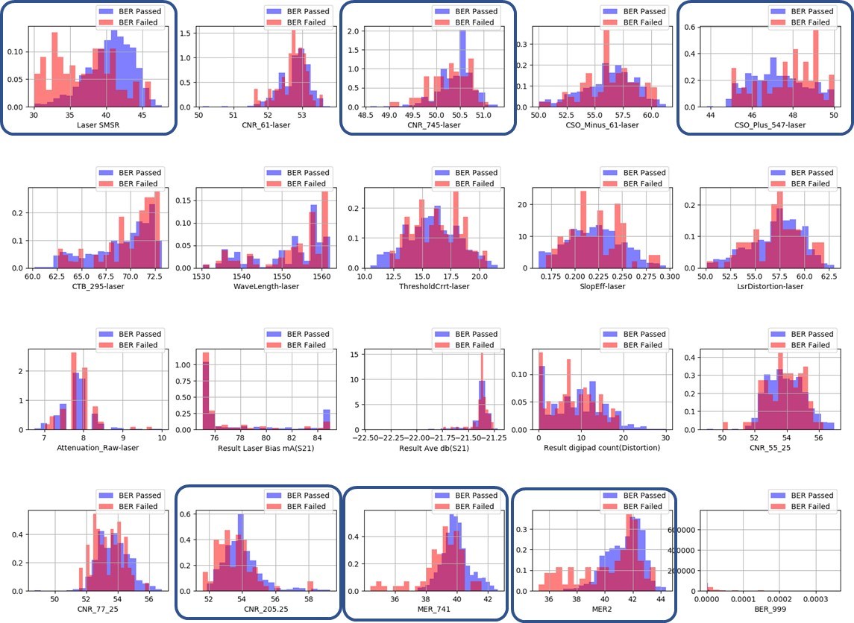
As we see, most of the lasers that failed have lower SMSR values compare to the passed units. CNR-745 is also a little bit skewed to the left for the failed units. It is interesting to note that CSO547 feature is high even for the failed units. It also seems like that the laser bias distribution is very similar for the passed and failed units. It could also make sense that some of the failed units have small MER values compare to the passed units. In the transmitter side, CNR values are also skewed to the lower values for the failed units. Now, let’s use random forest to see which of the features give more information regarding the BER test. At this step, we ignore the 'MER_741', 'MER2','BER_999' since they are just somehow present the BER test results and are the final measurements.
Feature | Feature Importance Value
Laser SMSR | 0.299339872
WaveLength-laser | 0.095235411
SlopEff-laser | 0.080318554
CSO_Plus_547-laser | 0.070718063
CNR_205.25 | 0.069868844
CNR_55_25 | 0.069244658
Result Ave db(S21) | 0.05027154
CNR_77_25 | 0.047552873
Result Laser Bias mA(S21) | 0.032725861
ThresholdCrrt-laser | 0.031699015
CTB_295-laser | 0.030854107
CNR_745-laser | 0.026675522
Result digipad count(Distortion) | 0.025136019
CSO_Minus_61-laser | 0.022720245
LsrDistortion-laser | 0.022133346
CNR_61-laser | 0.017113353
Attenuation_Raw-laser | 0.008392716

This one shows that Laser SMSR, wavelength and slopeff play an important role in BER test results. It could also be mentioned that the laser bias data doesn’t show strong impact on the BER, however, we know Slopeff effects the laser bias. It could be interpreted as the measured laser bias data doesn’t provide enough information on the BER test however, physically it impacts the BER test and its impact comes from the Slopeff feature. Also, CSO547 and CNR measurements at the transmitter side have the next important impact on the BER test results. In the following we try to use clustering to find out if there is any specific feature that can be used to separate the failed units and passed units or not.
If we run the clustering on our dataset, we get the following result.
cluster | number of Passed | number of Failed | Failure Percentage
0 | 117 | 6 | 4.87 %
1 | 222 | 23 | 9.38 %
2 | 120 | 12 | 9.09 %
3 | 145 | 8 | 5.2 %
4 | 243 | 34 | 12.27 %
It should be mentioned that Total Failure Percentage = 8.92%.
As the result shows, clusters 0 and 3 have lower failure percentage. By looking at the clusters centers for each feature we might get some insight about the specific detail on these two clusters. Following is the result for each cluster’s center.
 | Cluster 0  Center | Cluster 1  Center | Cluster 2  Center | Cluster 3  Center | Cluster 4  Center
Laser SMSR | 39.5602 | 39.6691 | 40.3642 | 41.0461 | 40.4434
CNR_61-laser | 52.6715 | 52.8600 | 52.7394 | 52.7118 | 52.7819
CNR_745-laser | 50.3496 | 50.4829 | 50.3591 | 50.3451 | 50.4025
CSO_Minus_61-laser | 57.1390 | 56.1898 | 56.1258 | 55.7850 | 56.2480
CSO_Plus_547-laser | 48.0415 | 47.1024 | 47.5394 | 47.2373 | 47.1310
CTB_295-laser | 69.2878 | 69.5576 | 68.6068 | 69.1882 | 69.0736
WaveLength-laser | 1538.9291 | 1556.3891 | 1538.5032 | 1556.5489 | 1556.6485
ThresholdCrrt-laser | 16.1829 | 16.9633 | 14.7326 | 16.3144 | 15.3643
SlopEff-laser | 0.2345 | 0.2265 | 0.2201 | 0.1979 | 0.2213
LsrDistortion-laser | 58.0724 | 57.1122 | 56.9644 | 56.6222 | 57.1711
Attenuation_Raw-laser | 7.9451 | 7.8969 | 7.7216 | 7.8840 | 7.7175
Result Laser Bias mA(S21) | 75.5874 | 75.7472 | 78.4454 | 83.7214 | 76.1821
Result Ave db(S21) | -21.3543 | -21.3583 | -21.4039 | -21.4441 | -21.3611
Result digipad count(Distortion) | 13.3984 | 15.6735 | 3.3864 | 2.0784 | 7.1733
CNR_55_25 | 53.7619 | 53.7858 | 54.3417 | 53.9814 | 53.8692
CNR_77_25 | 53.7580 | 53.5487 | 54.1522 | 53.7238 | 53.6066
CNR_205.25 | 53.9495 | 53.6690 | 54.3292 | 54.2037 | 53.7290
To have a better insight for these numbers, we can use a bar plot to see all of them. Following is the same numbers in bar plot formats.
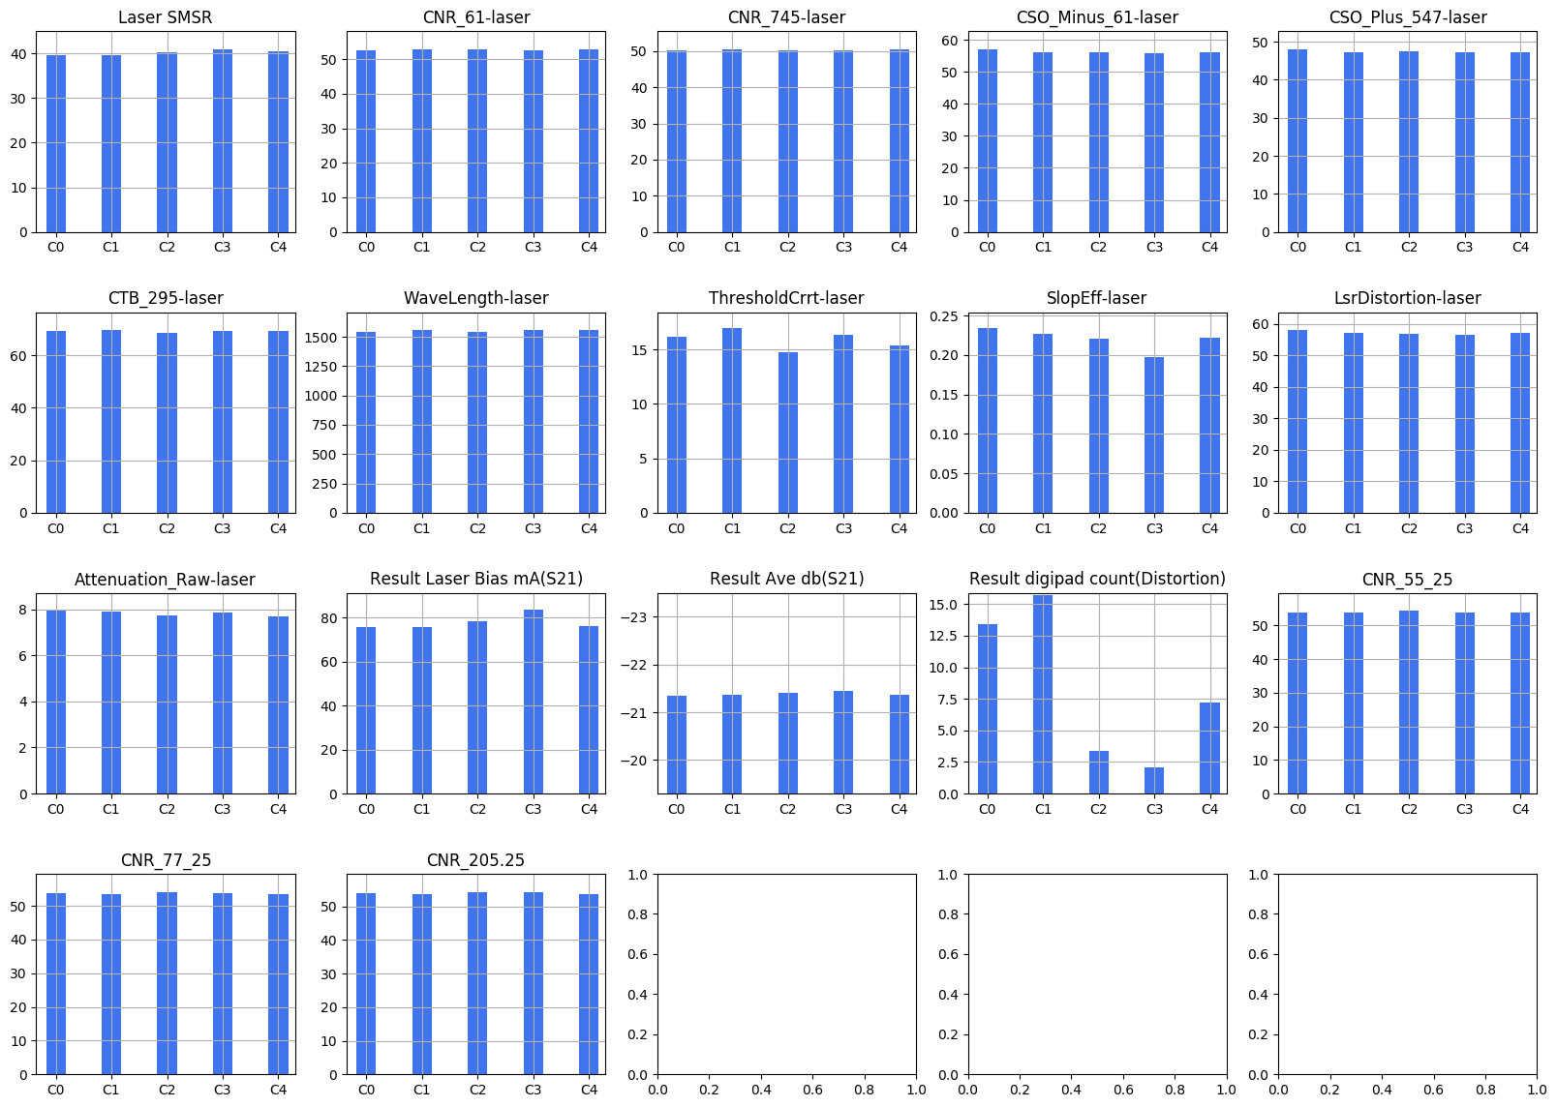
If we look at the clusters 0 and 3 ‘s centers, we don’t see a specific pattern repeated for these two clusters that is different than the other cluster centers. It seems like that there is no correlation between clusters centers and the failure percentage. But there is a point to mention out of this result and it is for cluster 3. This cluster has a smallest center value for Slopeff which leads to highest laser bias and lowest digipad_count(distortion). We knew the first relation between the slopeff and laser bias. For the second one, it is intersing that the lasers which have higher bias in the transmitter they have smallest value for distortion measure at the transmitter station.
In the following, we investigate on SMSR value. Based on the histograms, we found that SMSR value for the failed units is lower compare to the passed units. If we use the threshold of 35 for SMSR, we get the following results.
- Number of Passed Units with SMSR<35 = 48
- Number of Failed Units with SMSR<35 = 31
- Failure percentage for SMSR<35 = 40.24 %
- Compare to 9.22% failure rate in total of the units (87 failed out of 943), we have a large number of failed units in SMSR<35.
If we plot the histogram of the units with SMSR<35, we have the following results:

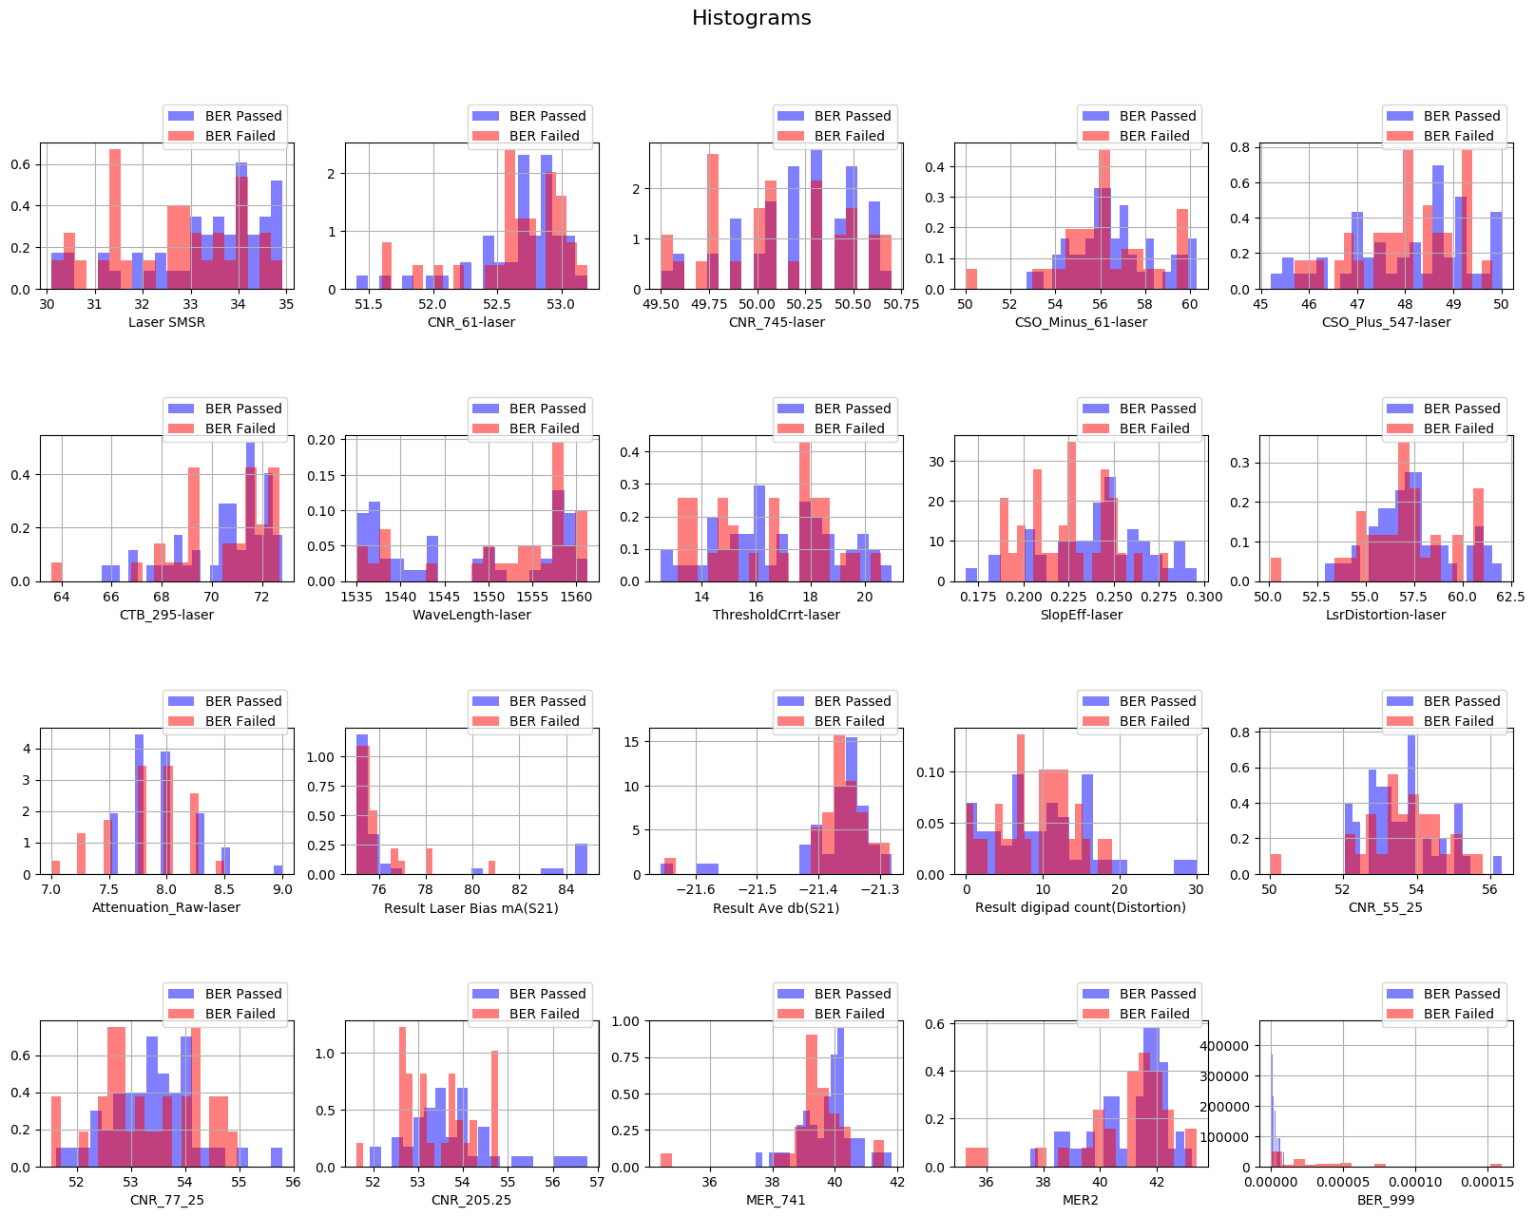
Now, if we only consider the units with SMSR>=35, we get the following statistics:
- Number of Passed Units with SMSR>=35 = 808
- Number of Failed Units with SMSR>=35 = 56
- Failure percentage for SMSR>=35 = 6.48 %
- Compare to 9.22% failure rate in total of the units (87 failed out of 943), we can lower down the failure rate by 3% only by filtering the SMSR values.
If we plot the histogram of the units with SMSR>=35, we get the following results:
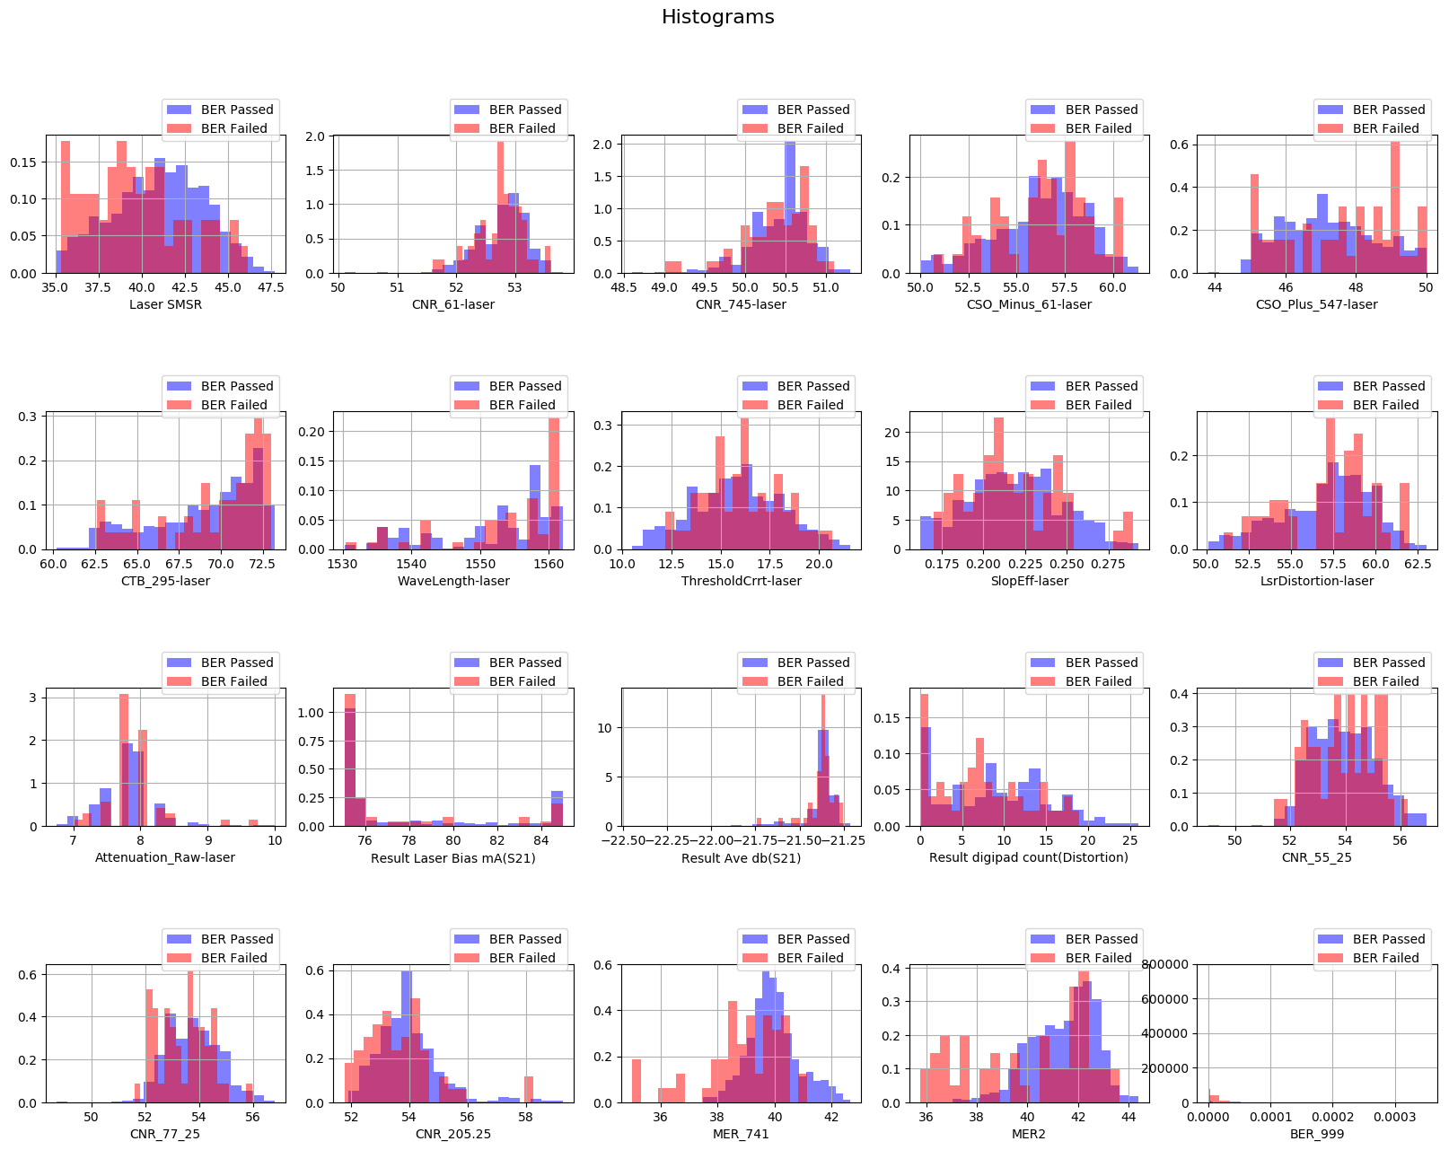
Now, if we run the machine learning algorithm to find out the important features on the units with SMSR>=35 to predict the BER test result, we get the following values:
Feature | Feature Importance Value
WaveLength-laser | 0.171043233
Laser SMSR | 0.139026982
Result Ave db(S21) | 0.093513295
CNR_55_25 | 0.090780872
Result Laser Bias mA(S21) | 0.078802025
CSO_Plus_547-laser | 0.078118796
CNR_205.25 | 0.075098259
ThresholdCrrt-laser | 0.047792737
CNR_77_25 | 0.045711407
SlopEff-laser | 0.037513397
Result digipad count(Distortion) | 0.028163511
Attenuation_Raw-laser | 0.024418957
CTB_295-laser | 0.024263561
CSO_Minus_61-laser | 0.022021192
CNR_61-laser | 0.018502661
LsrDistortion-laser | 0.015301248
CNR_745-laser | 0.009927868
This result shows that wavelength of the laser alongside with the SMSR play important role. It is interesting that, the slopeff which was an important factor for all the units for the units with SMSR>=35 is not that much important. Also, if we look at the Wavelgnth histogram, we observe that units with wavelength >=1560 nm are very dominant in failed units. If we filter by this feature, we get the following result:
- Number of Passed Units with SMSR>=35 and Wavelength>=1560 = 108
- Number of Failed Units with SMSR>=35 and Wavelength>=1560 = 18
- Failure percentage for SMSR>=35 and Wavelength>=1560 = 14.28 %
- Compare to 6.48 % failure rate in all the units with SMSR>=35 (56 failed out of 864), we have higher number of failed units with Wavelength>=1560.
Following is the histogram of the units with SMSR>=35 and Wavelength>=1560.
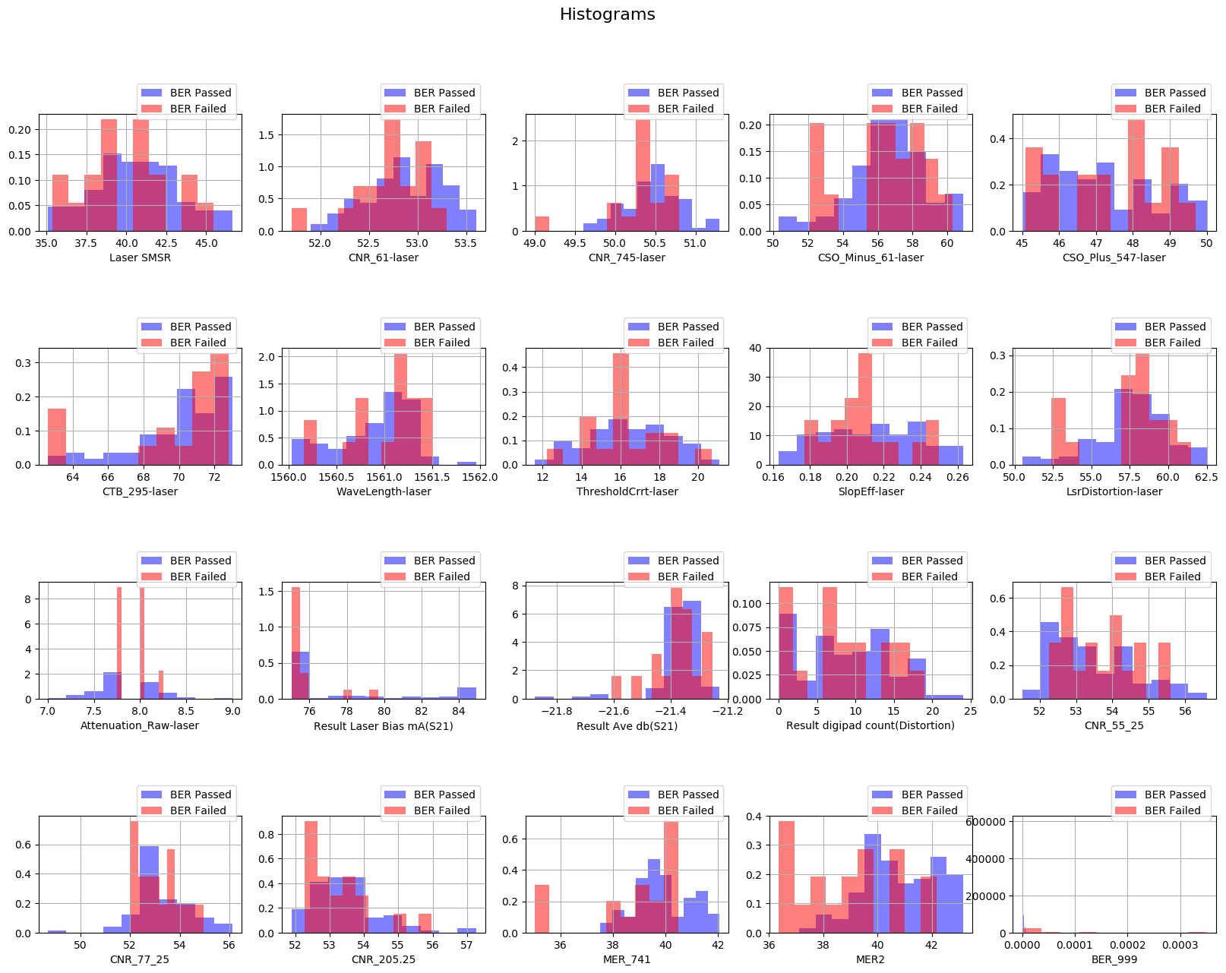
It is very interesting that the filed units inside this category, they have laser bias of <76 mA. And almost all the others than have high laser bias passed the BER test. (see the laser bias histogram)
For the units with SMSR>35 and Waveelngth<1560, we get the following results:
- Number of Passed Units with SMSR>=35 and Wavelength<1560 = 700
- Number of Failed Units with SMSR>=35 and Wavelength<1560 = 38
- Failure percentage for SMSR>=35 and Wavelength<1560 = 5.14 %
- Compare to 6.48 % failure rate in all the units with SMSR>=35 (56 failed out of 864), we can lower down the failure by 1.5% .
Following is the result for the units with SMSR>=35 and Wavelength<1560.
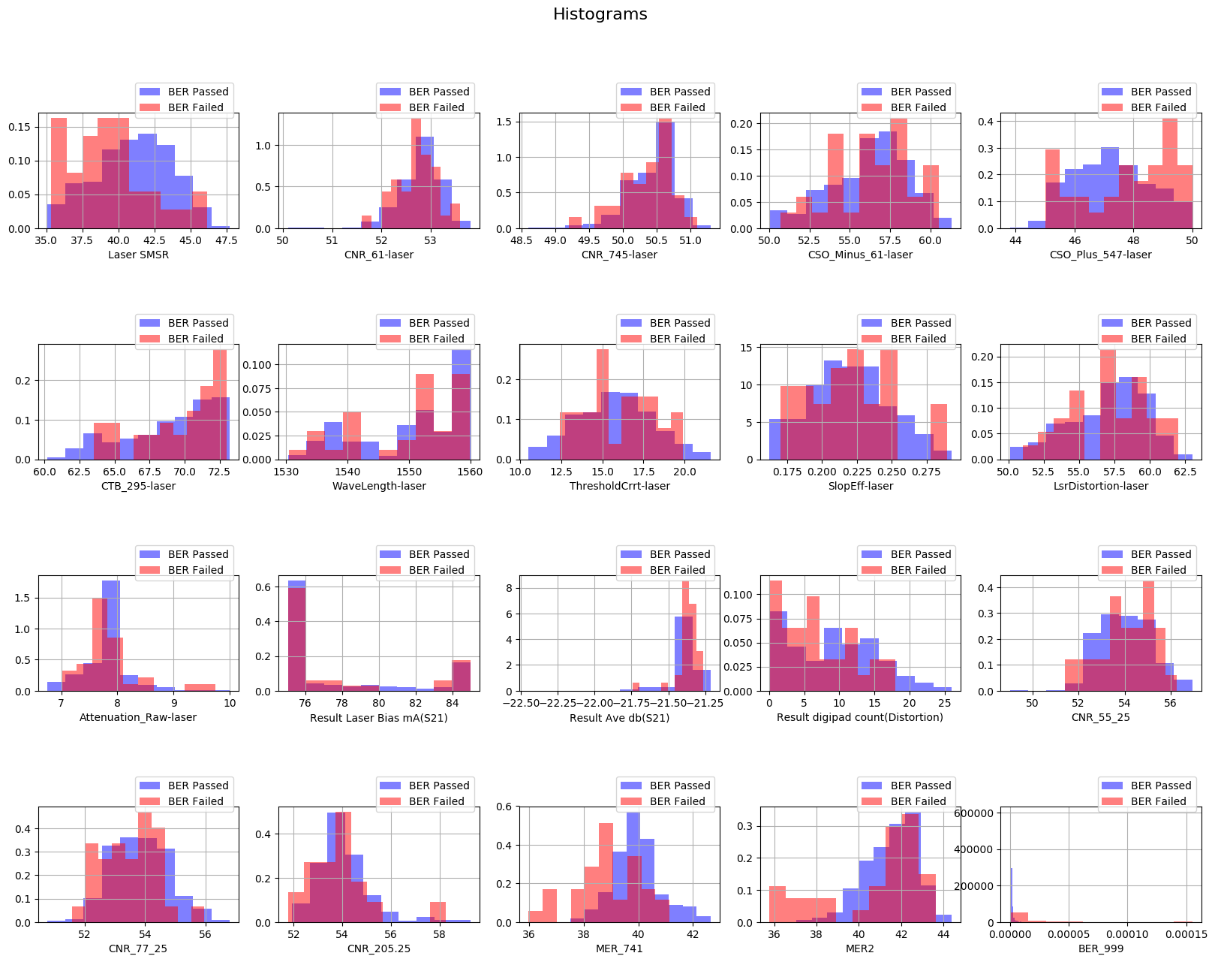
And now if we run the machine learning algorithm to find the feature importance on the units with SMSR>=35 and Wavelength<1560, we get the following result:
Feature | Feature Importance Value
Laser SMSR | 0.198835753
CNR_55_25 | 0.114828572
CSO_Plus_547-laser | 0.104318323
CNR_77_25 | 0.065984443
Result Ave db(S21) | 0.06480284
CNR_205.25 | 0.063336006
SlopEff-laser | 0.05738905
Result digipad count(Distortion) | 0.043747396
Attenuation_Raw-laser | 0.043728521
WaveLength-laser | 0.043324115
Result Laser Bias mA(S21) | 0.041730336
ThresholdCrrt-laser | 0.031397329
CTB_295-laser | 0.030280084
CNR_745-laser | 0.028586609
LsrDistortion-laser | 0.02560533
CNR_61-laser | 0.023284654
CSO_Minus_61-laser | 0.01882064
We see that laser SMSR, and CSO547 are important as well as CNR55.25 of the transmitter. By looking at the histogram of these feature we can find out there they are skewed for the failed units compare to the passed one.
In conclusion, SMSR and Wavelength could be use as initial features to investigate the failed units in more detail. Also, after filtering these features, it might be helpful to run more analysis and by using more data to investigate the possible reasons for failure. This report considers a roadmap of how we can investigate the failure results step by step. Making a decision will be made after more investigations and tests. It should be mentioned that gathering more data appropriately would help a lot in the analysis. Having data with lack of accuracy would lead to wrong decisions at the end. Furthermore, the data set that we used so far shows that the failure result depends less on the laser bias. In fact, it depends on laser bias after some filtering on SMSR. So, to achieve better prediction on laser bias, we would need to run other tests and measure other data such as full BER curve versus the optical power. Otherwise, using only the current laser bias data which is measured only by achieving the optical power wouldn’t help. Also, considering the physics of the lasers and BER test would help a lot in order to define new experiments. Using data analysis, we found different correlation that by combining with the physics of the phenomena we can have better and more accurate predictions.

